Managing Director Appointment

Michael Currier appointed Managing Director for Schöck Ltd.

The continuing growth of Schöck Ltd in the UK is now further underpinned by the appointment of Michael Currier as Managing Director. Michael, who was previously National Sales Manager, took up his new position on January 1st.

His key responsibilities are for the planning and implementation of marketing and sales strategy, along with the development of technical and engineering support. The Isokorb® range of thermal break modules dominates the market throughout Europe; and since its formal introduction to the domestic market some five years ago, is now market leader here as well. It is this success and the introduction of other innovative Schöck construction products that has led to the demand for an active Managing Director, who takes over the responsibility for all Schöck Ltd activities in England, Wales and Scotland.

Michael comments: “We have a very professional sales team, well supported by the Bloxham technical facility in Oxfordshire, which provides full design, technology and consultancy services on all aspect of the company’s products. The continued expansion of the Schöck operation here and the likelihood of new product introductions as well mean that there are a number of strategic issues to be addressed and there is a busy and exciting time ahead. One of my main priorities is certainly to ensure that the products and services we offer to specifiers, engineers and contractors remain the most comprehensive on the market”.

After qualifying at Guildford County Technical College, Michael Currier first worked as site engineer and then site manager for a local building contractor, eventually moving on to a specialist concrete frame contractor. He was handed the responsibility of establishing a new start access scaffolding operation for the company, which he ran successfully for six years before returning to the concrete frame side of the business at director level.

In 2001 Michael took his extensive experience to Buildspan, a specialist concrete accessories and construction products distributor based in West Surrey. His role was to spearhead the introduction of the Schöck Isokorb® range of products – which were ideal in meeting the exacting cold bridging prevention requirements of the Building Regulations 2002 Part L.

These innovative products were extremely well received and when the strategic decision was taken to market the Isokorb® direct in early 2006, Michael joined Schöck Ltd to become one of its first sales and technical consultants.

- Ends –

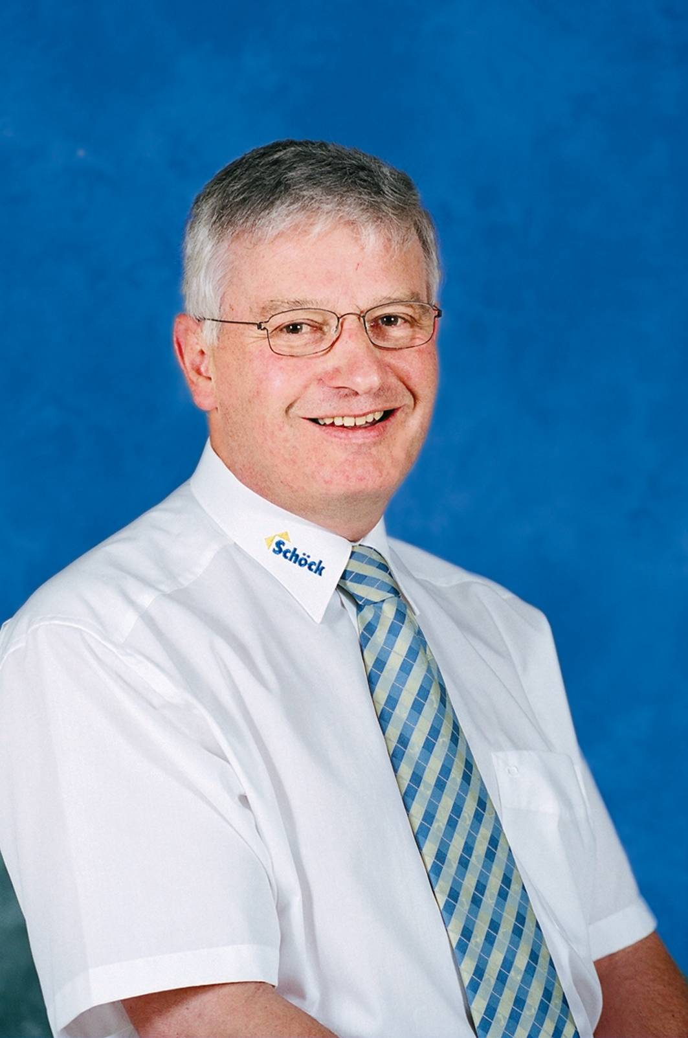
Caption: Michael Currier
Notes to the editor

A leading European supplier
Schöck has grown to become Europe’s leading supplier of innovative structural load bearing insulation products. Its headquarters are at Baden-Baden in southern Germany and there are subsidiary companies in Great Britain, France, Austria, Switzerland, the Netherlands, Belgium, Poland, Italy and Hungary. Sales teams and partners operate in many other European countries and also Canada and the Middle East. Schöck is committed to providing the highest level of technical back up and comprehensive customer service to the construction industry.

