Press Release.

Schöck Restructures Executive Board for the Next Phase of Development
Dr. Andreas Löber will become Chief Financial Officer effective January 1, 2027, and will lead the Schöck Group alongside CEO Alfons Hörmann

Baden-Baden, October 26 – Schöck AG is restructuring its executive leadership for the coming years: Effective January 1, 2027, Dr. Andreas Löber will join the Executive Board and assume responsibility for finance, as well as for human resources, IT, procurement, and logistics. Together with CEO Alfons Hörmann, he will lead the Schöck Group going forward. With this move, Schöck is laying the organizational groundwork for the next phase of the company’s development.

With this step, the Schöck Group is setting the course for the coming years. The new Executive Board structure will distribute responsibilities more broadly and create the necessary capacity to consistently address growing complexity and strategic tasks.

Alfons Hörmann, CEO of Schöck AG, explains:
“Following an intensive phase of restructuring and stabilization, the focus now is on consistently advancing Schöck and capitalizing on new opportunities. To do this, we need a leadership structure that combines clear responsibility with a high degree of autonomy. With Andreas Löber, we have a colleague on the Executive Board who knows our company very well and has taken on increasing responsibility in recent years. Together, we aim to strengthen our core business, expand our portfolio in a targeted manner, and position Schöck for sustainable growth in the coming years.”

Dr. Andreas Löber has been with Schöck since 2023. Initially, he was responsible for IT, SAP, and processes. His area of responsibility was subsequently expanded on an ongoing basis. Since early 2026, he has served as Managing Director of Schöck Bauteile GmbH and has already played a key role in the financial management of the Schöck Group. With his appointment to the Executive Board, Schöck is deliberately focusing on continuity and internal expertise.

Dr. Andreas Löber comments:
“I am very pleased about the trust placed in me and the opportunity to assume even broader responsibility for Schöck on the Executive Board in the future. We have a strong foundation and a wealth of experience within the company. We want to build on that while also having the courage to tap into new potential. My goal is to work together with Alfons Hörmann and the entire team to successfully shape Schöck’s next phase of development.”

The Supervisory Board also views the new management structure as a logical step for the company’s further development.
Nikolaus Wild, Chairman of the Supervisory Board of Schöck AG, explains:
“With the appointment of Dr. Andreas Löber, we are deliberately focusing on continuity and expertise from within our own ranks. He knows Schöck, its structures, and the current challenges from his day-to-day responsibilities. The Supervisory Board is convinced that Alfons Hörmann and Dr. Andreas Löber, as the Executive Board team, possess the right qualifications to continue the company’s successful development while also opening up new strategic perspectives.”

Images

[Schoeck_New_CFO_01]
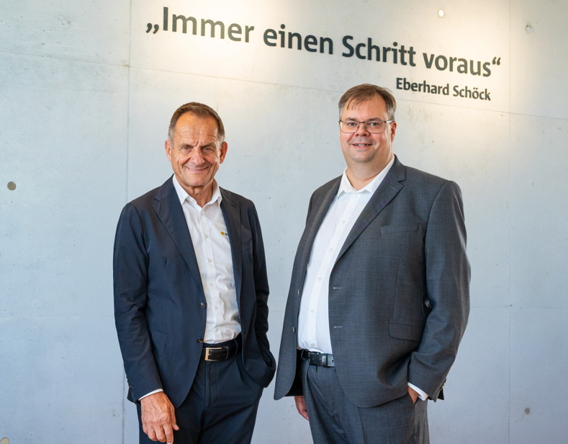
Effective January 1, 2027, Schöck AG will expand its Executive Board: Dr. Andreas Löber will lead the Schöck Group alongside CEO Alfons Hörmann.
Photo: Schöck AG

[Schoeck_New_CFO_02]
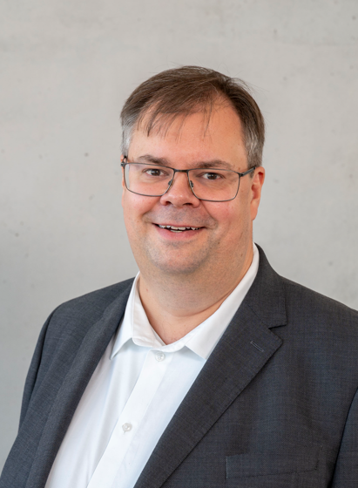
Effective January 1, 2027, Dr. Andreas Löber will join the Schöck Executive Board and assume responsibility for the Finance division.
Photo: Schöck AG

