Schöck dowels take the strain on major Cairo project

After almost four years of construction, the Goethe Institute Cairo, at 17 Sharia Wassef in the Dokki district on the west bank of the Nile was completed in June 2016. A constantly growing demand for German courses and cultural programmes made it necessary to both expand the facilities and relocate the institute. The new group of buildings now has over 15 multimedia classrooms and one of the most modern event halls in Cairo. A central element in the newly constructed building is a library, which can also be used as a meeting room and for dialogue.

For almost 60 years the Goethe Institute in Cairo has been a cultural meeting point and until recently was spread across several locations in the city. By centralising the facilities, the rooms in the new institute now provide more opportunities for language courses, events with music, theatre, dance and discussion forums than ever before. The project for the renovation and new build, at a former GDR property at Sharia Hussein Wassef in Dokki, was managed by the foreign department of the German Federal Office for Building and Regional Planning (BBR). A derelict two-storey villa standing on the land was reconstructed, the adjacent outbuildings were torn down and an extensive group of new buildings was constructed. All public areas of the institute are now on this site.

Modern architecture combined with traditional Arabic building design.
In 2007, the Erfurt firm, Worschech Architekten Planungsgesellschaft mbH, a general planner (GP), won the design competition organised by the BBR with their proposal for the renovation and new build of the Goethe Institute.

Under the project management of Marcus Johansson, a highly effective planning team was brought together very early in the process, ready for the progressive planning phases including construction supervision. An overriding aspect was to retain the large garden which included a considerable number of palm trees.

As a result the new build was therefore deliberately positioned around the edge of the garden, reminiscent of Arabic inner courtyards, with the elevations sympathetic to the neighbouring villas. The new group of buildings comprises a villa, a hall with a library above and an adjacent line of classrooms. This line extends along the southern edge of the site and borders the second, inner garden area. Seventeen classrooms are accommodated in loose groups of cubes, which are connected to one another by means of a loggia, which opens onto the garden and is slightly elevated on the ground floor. With its clear, cubic structures, a façade made from light-coloured exposed concrete and large window areas, the building follows the tradition of the Bauhaus modern style. However, the stepped structure of the individual components and ornamentally perforated metal balconies also make reference to Egyptian building traditions. The result is an open, transparent building, which blends harmoniously with its surroundings.

Project Coordination was a challenge
“The Institute was planned and constructed at a very turbulent time in Egyptian politics. The challenge was to coordinate the construction work since many building materials and parts that are commonplace in Germany were not available locally. For example, dowels from the building component manufacturer, Schöck GmbH from Baden-Baden, that were used as loadbearing connectors between the building sections, had to be flown in specially. In those difficult times, which included curfews, workers could not get to the building site and lorries were not allowed on the roads to bring supplies to the building site. This meant that the construction time almost doubled. The client, the BBR, showed a lot of understanding for the delay,” according to Mamdouh Habashi, from the local construction company, Al Habashi in Cairo.

Mamdouh Habashi knows both cultures well because the native Egyptian studied construction engineering at the technical university in Berlin. “It is, of course, an advantage for such a project to understand the Arabic mentality but also to have experience in working with the German authorities, architects and civil engineers.” When building the Goethe Institute, the construction company was able to use innovative, environmentally friendly methods. For example, ground water is being used for air conditioning the rooms and then recycled, a method that is being used for the first time in the MENA region.

Construction work is earthquake resistant and watertight
The new Goethe Institute complex in Cairo consists of three building sections. In the first part there is the hall on the ground floor and above this the library, as well as the language department. In the second part of the building, the suite of classrooms for German courses is accommodated and the third building is the reconstructed villa. The stringent requirements for earthquake resistance made the reconstruction of the derelict villa from the colonial era necessary. “All of the buildings are built on sand. The lower floor was constructed in a watertight manner since the ground water level lies above the level of the foundations due to the proximity to the Nile,” explains Peter Muecke from R&P Ruffert Ingenieurgesellschaft mbH from Erfurt. “The four-storey building was built in reinforced concrete in solid construction style. Vertical load is transferred using pillars and walls arranged at irregular intervals. A two centimetre wide expansion joint was arranged between the building sections containing the hall and classroom suite in the region of a connecting bridge across all levels. In order to rule out the transfer of horizontal forces resulting from earthquake loads, Schöck shear force dowels type ESD-SQ 30/350 from Schöck Bauteile GmbH were used to transfer vertical loads. Schöck dowels were the most economical and practical solution here, since it was not possible to construct reinforced concrete corbels owing to the very slim building section dimensions.

Schöck dowels as connectors
In concrete structural components, which move towards each other, creep and contraction of the concrete due to temperature fluctuations, can lead to considerable loads and therefore cracks or other structural damage. This is why expansion joints are installed. These expansion joints can separate single structural components or entire building sections, as in this case. They allow one building section to expand independently of the other section. The elements separated by the joint must, however, be supported in the region of the joints. Corbels with sliding supports were conventionally used to do this. Alternatively, a double structure of loadbearing walls and pillars can be used at the structural joints. This approach is, however, costly to reinforce and line, and also requires space which limits finishing and later use. Schöck dowels offer a simpler solution. They are ready to install and therefore facilitate simple planning and formwork, so reinforcement layouts are simplified as a result. Schöck dowels transfer high shear forces into the expansion joints allowing simultaneous movability along and transversely to the dowel axis. By using high-quality stainless, steel, reliable and maintenance-free connection is ensured. The correct Schöck dowels are selected for their load-bearing capacity specific to the installation demands. Schöck dowel design software allows quick and easy sizing of expansion joints using Schöck dowel types SLD and LD.

A long journey pays off
Many years of planning and almost four years’ construction time have paid off – making it an even more joyous occasion when it was possible to open the new buildings in 2016, with the celebrations lasting several days. Hagen Thiele, Project Manager at BBR summarises the situation: “The concept has proven successful; all of the building’s components work. We hope that this place will become a meeting point for creativity and intercultural exchange so that this relocation will lead to fresh perspectives in the spirit of the Goethe Institute.”
(7,933 characters with spaces)
- Ends -

Project Team

Architect: Worschech Architekten Planungsgesellschaft mbH, Erfurt
Landscape architect: Kokenge Ritter, Dresden

Structural engineer: Ruffert Ingenieurgesellschaft für Tragwerksplanung mbH, Erfurt

Construction company: AL HABASHI General Contracting, Cairo

Client: Federal Office for Building and Regional
Planning, Department III A 4, Berlin

Schöck products: dowel type SLDQ60, dowel type ESD-SQ30-350

Press Contact for Schöck Ltd:
Michael Revans Communications
47 Barn Rise, Wembley Park,
HA9 9NH

tel: 020 8904 9733
e: michael.revans1@btinternet.com

Notes to the editor

A leading European supplier
Schöck has grown to become Europe’s leading supplier of innovative structural load bearing insulation products. The main product is the Schöck Isokorb – a thermal break for various types of cantilever constructions in new buildings and for renovation. Its headquarters are at Baden-Baden in southern Germany and there are subsidiary companies in Great Britain, France, Austria, Switzerland, Italy the Netherlands, Belgium, Poland, Hungary, Russia, Japan, Canada and the USA. Sales teams and partners operate in many other European countries and also Australia and South Korea. Schöck is committed to providing the highest level of technical back up and comprehensive customer service to the construction industry.

Images and captions

[Goethe Institute Cairo_total view.jpg]
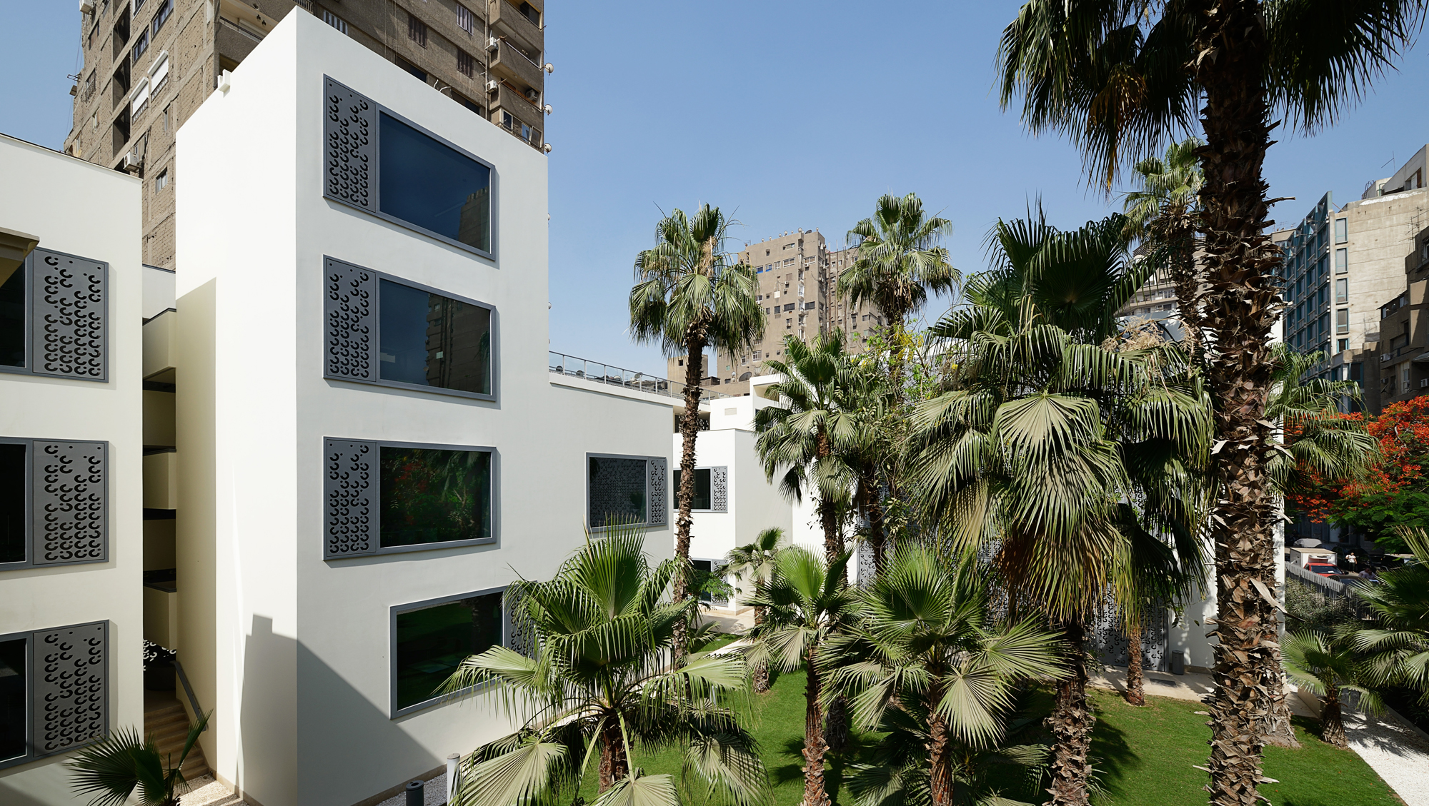
The constantly growing demand for German courses and cultural programmes made it necessary to expand and relocate the facilities of the Goethe Institute in Cairo. Image: Stephan Genge

[Goethe Institute Cairo.jpg]
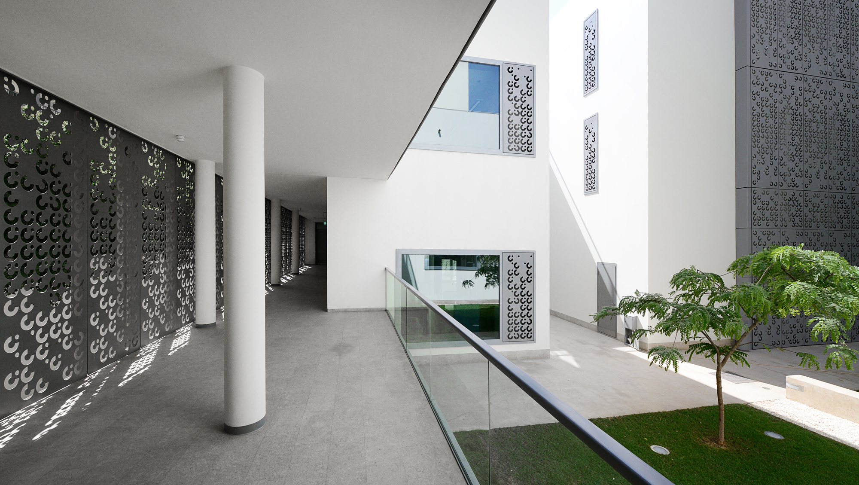
In order to avoide damages caused by temperature fluctuations at the connection of two concrete components, expansion joints with integrated dowel by Schöck are installed.This dowel transfers high shear forces into the expansion joints allowing simultaneous movability along and transversely to the dowel axis. Image: Stephan Genge.

[Dowel type SLD.jpg]

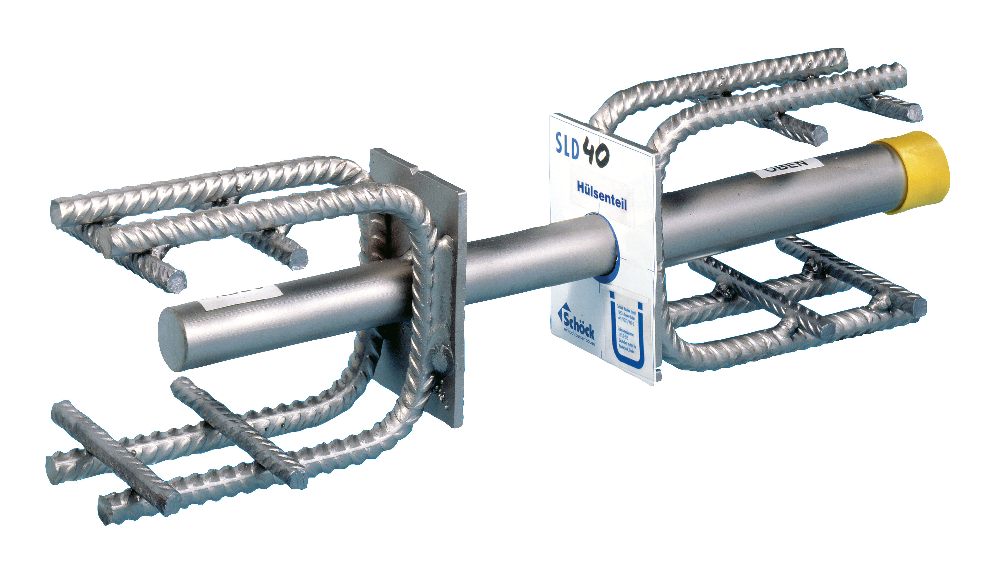

Structures without slab joists and cantilevers can be realised with the Schöck dowel SLD, which acts as a slab support. Image: Schöck Bauteile GmbH.

[Dowel type ESD.jpg]

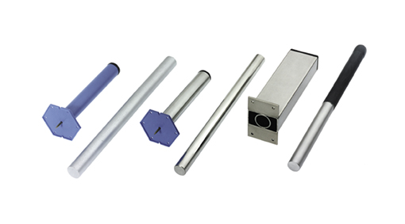

The ESD single shear dowel transmits forces where construction joints
experience small loads – such as those between balcony slabs, roadway slabs
and cantilever retaining walls. Image: Schöck Bauteile GmbH.

For questions and feedback, please contact
Schöck Bauteile GmbH
Wolfgang Ackenheil
Tel.: 0 72 23 – 967-471
Fax: 0 72 23 – 9677-471
E-mail: presse@schoeck.de
www.schoeck.de

